«Targeting the RNA World:
Using Chemistry to Understand RNA Biology».

International Research Workshop

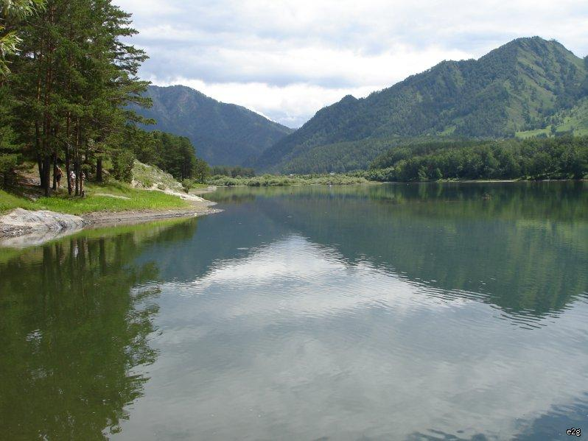

Nika Mansion House, Usnezya Village, Altai, 24th – 30th August 2015

The international research workshop is organized by Institute of Chemical Biology and Fundamental Medicine Siberian Branch of Russian Academy of Sciences (ICBFM SB RAS), Lavrentieva ave. 8, Novosibirsk 630090, Russia

The international research workshop is supported by Russian Scientific Found grant № 14-44-00068

PROGRAMME
International Research Workshop
Targeting the RNA World: Using Chemistry to Understand RNA Biology
Nika Mansion House, Usnezya Village, Altai, 24th – 30th August 2015

Monday 24th August
18:00 – 19:00 | Opening Ceremony  Introduction to the Scientific Project  Prof. Marina A. Zenkova, Institute of Chemical Biology and Fundamental Medicine, Novosibirsk, Russia  Dr. Elena V. Bichenkova, University of Manchester, UK
19:00 | Dinner

Tuesday 25th August
9:00 – 13:00 | Excursion
13:00 – 14:00 | Lunch

Session 1. Peptides and other molecules: oligonucleotide conjugates as tools for RNA research
Chair: Dr. Elena V. Bichenkova, University of Manchester, Manchester, UK
14:00 – 15:00 | New methods in peptide synthesis  Dr. Dmitry A. Stetsenko, Institute of Chemical Biology and Fundamental Medicine, Novosibirsk, Russia
15:00 – 16:00 | siRNA – peptide conjugates  Prof. Masayuki Fujii  Department of Environmental and Biological Chemistry, Kinki University, Iizuka, Fukuoka, Japan
16:00 – 16:30 | Developing a New Generation of Peptidyl-Oligonucleotide Conjugates with Desirable Biocatalytic Properties  Aled Williams, University of Manchester, UK
16:30 – 17:00 | Coffee Break
17:00 – 17:30 | Different approach to design modified oligonucleotides  Maxim S. Kuprushkin, Institute of Chemical Biology and Fundamental Medicine, Novosibirsk, Russia
17:30 – 18:00 | Novel Ribonuclease Mimetics: Investigation of 3D Structure and Dynamic Behavior by 2D NMR Spectroscopy  Linda Trivoluzzi, University of Manchester, UK
18:00 – 18:30 | Spin-labeled oligonucleotides - useful tool for the structural investigations  Georgiy Shevelev, Institute of Chemical Biology and Fundamental Medicine, Novosibirsk, Russia
18:30 – 19:00 | Notes on amphiphiles: peptides and more  Dr. Pasquale Palladino, Dipartimento di Scienze Chimiche, Università degli Studi di Catania, Catania, Italia
19:30 – 22:00 | Get-together party

Wednesday 26th August
9:00 – 13:00 | Excursion
13:00 – 14:00 | Lunch

Session 2. Structural insights into RNA functions
Chair: Prof. Marina A. Zenkova, Institute of Chemical Biology and Fundamental Medicine, Novosibirsk, Russia
14:00 – 15:00 | From basic science to medicine: use of NMR and X-ray in modern drug discovery  Dr. Elena V. Bichenkova, University of Manchester, UK
15:00 – 16:00 | Computer-aided molecular design  Dr. Richard A. Bryce, University of Manchester, UK
16:00 – 16:30 | Physicochemical properties of the nucleic acid derivatives: experiment vs molecular dynamics simulations  Dr. Alexander A. Lomzov, Institute of Chemical Biology and Fundamental Medicine, Novosibirsk, Russia
16:30 – 17:00 | Coffee Break

17:00 – 18:00 | Applications of p53 interactome analysis to personalised cancer therapy  Prof. Marija Kristic-Demonacos, University of Salford, UK
18:00 – 18:30 | The impact of chemical modifications on the carrier-free uptake and silencing activity of siRNA in hematopoietic and cancer cells  Ivan Chernikov, Institute of Chemical Biology and Fundamental Medicine, Novosibirsk, Russia
18:30 – 19:00 | Visualization of different conjugates and complexes of therapeutic siRNA in mice  Daniil Gladkih, Institute of Chemical Biology and Fundamental Medicine, Novosibirsk, Russia
19:00 – 19:20 | Search for correlation between concentration of extracellular DNA and deoxyribonuclease activity of blood plasma of patients with different tumors under the treatment with DNase I in oral form (O’Shadi D)  Ludmila Alekseeva, Institute of Chemical Biology and Fundamental Medicine, Novosibirsk, Russia
19:20 – 19:50 | Immunotherapy of hepatocellular carcinoma and melanoma with 22-nt double-stranded RNA  Dr. Tatyana Kabilova, Institute of Chemical Biology and Fundamental Medicine, Novosibirsk, Russia
20:00 – 21:00 | Dinner

Thursday 27th August
9:00 – 13:00 | Excursion
13:00 – 14:00 | Lunch

Session 3. RNA-targeting agents as prospective antiviral or anticancer drugs
Сhair: Prof. David J. Clarke, University of Manchester, UK
14:00 – 15:00 | Infections transmitted by ticks  Prof. Valentin V. Vlassov, Institute of Chemical Biology and Fundamental Medicine, Novosibirsk, Russia
15:00 – 15:45 | Anti-influenza and anti-inflammatory activity of new glycyrrhetinic acid derivative Soloxolone methyl  Dr. Eugenia Logashenko, Institute of Chemical Biology and Fundamental Medicine, Novosibirsk, Russia
15:45 – 16:30 | Artificial ribonucleases as a new class of antiviral agents  Dr. Elena Goncharova, Institute of Chemical Biology and Fundamental Medicine, Novosibirsk, Russia
16:30 – 17:00 | Coffee Break
17:00 – 17:30 | Effect of Soloxolon Methyl on gene expression profiles in epidermoid carcinoma cells: a DNA microarray analysis  Andrej V. Markov, Institute of Chemical Biology and Fundamental Medicine, Novosibirsk, Russia
17:30 – 18:30 | Cytochrome P450 profiling as a tool to plan anticancer therapy and predict drug resistance in breast cancer  Dr. Konstantinos Demonakos, University of Manchester, UK
18:30 – 19:30 | RNase A caused rearrangement of intracellular pathways in tumor cells providing restoration of normal cell proliferation and differentiation  Dr. Nadezhda L. Mironova, Institute of Chemical Biology and Fundamental Medicine, Novosibirsk, Russia
19:30 – 20:00 | Site-specific cleavage of microRNA by oligonucleotide-peptide conjugates  Dr. Olga Patutina, Institute of Chemical Biology and Fundamental Medicine, Novosibirsk, Russia
20:00 | Dinner

Friday 28th August
9:00 – 13:00 | Excursion
13:00 – 14:00 | Lunch
Session 4. Diversity in the world of nucleic acids
Сhair: Dr. Elena L. Chernolovskaya, Institute of Chemical Biology and Fundamental Medicine, Novosibirsk, Russia
14:00 – 15:00 | Small regulatory RNAs in bacterial metabolism  Dr. Tatiana L. Azhikina, Shemyakin-Ovchinnikov Institute of Bioorganic Chemistry, Moscow, Russia
15:00 – 15:30 | Deoxyribozyme therapeutics: from in vivo experiments into clinical trials  Dr. Alesya A. Fokina, Institute of Chemical Biology and Fundamental Medicine, Novosibirsk, Russia
15:30 – 16:00 | Study of modified oligonucleotide uptake into mammalian cells by laser fluorescent confocal microscopy  Dr. Boris P. Chelobanov, Institute of Chemical Biology and Fundamental Medicine, Novosibirsk, Russia
16:00 – 16:30 | Coffee Break
16:30 – 17:30 | Graphene: Potential Applications in Biomedicine and Life Sciences  Prof. David Clark, University of Manchester, UK
17:30 – 18:30 | Analyzing of a random set of RNA species with NGS  Yaroslav Staroseletz, Institute of Chemical Biology and Fundamental Medicine, Novosibirsk, Russia
18:30 – 19:00 | Prophylactic dendritic cell-based anti-tumor vaccines is highly potential to treat murine metastatic tumors  Oleg V. Markov, Institute of Chemical Biology and Fundamental Medicine, Novosibirsk, Russia
19:00 – 19:30 | The toxic effect of tumor with multi-drug resistance phenotype on the liver: experimental study  Dr. Alexandra V. Sen`kova, Institute of Chemical Biology and Fundamental Medicine, Novosibirsk, Russia
19:30 – 19:40 | Closing of the workshop
20:00 | Conference Dinner

Saturday 29th August
9:00 – 19:00 | Excursion
20:00 | Dinner

Sunday 30th August
10:00 Departure to Novosibirsk

LIST OF PARTICIPANTS
Prof. Marina A. Zenkova (Institute of Chemical Biology and Fundamental Medicine, Novosibirsk, Russia)
marzen@niboch.nsc.ru

Dr. Elena V. Bichenkova (University of Manchester, UK)
Elena.V.Bichenkova@manchester.ac.uk

Yaroslav Staroseletz (Institute of Chemical Biology and Fundamental Medicine, Novosibirsk, Russia)
staroselec@niboch.nsc.ru

Dr. Dmitry Stetsenko (Institute of Chemical Biology and Fundamental Medicine, Novosibirsk, Russia)
dmitry.stetsenko@ntlworld.com

Prof. Marija Kristic-Demonacos (University of Salford, UK)

Aled Williams (University of Manchester, UK)
aled.williams@manchester.ac.uk

Prof. Valentin V. Vlassov (Institute of Chemical Biology and Fundamental Medicine, Novosibirsk, Russia)
vvv@niboch.nsc.ru

Maxim Kuprjushkin (Institute of Chemical Biology and Fundamental Medicine, Novosibirsk, Russia)
kuprummax@gmail.ru

Anton Filatov (Institute of Chemical Biology and Fundamental Medicine, Novosibirsk, Russia)
01111000@mail.ru

Georgiy Shevelev ((Institute of Chemical Biology and Fundamental Medicine, Novosibirsk, Russia)
shevelev@niboch.nsc.ru

Dr. A. Richard Bryce (University of Manchester, UK)
Richard.Bryce@manchester.ac.uk

Dr. Elena Chernolovskaya (Institute of Chemical Biology and Fundamental Medicine, Novosibirsk, Russia)
elena_ch@niboch.nsc.ru

Ivan Chernikov (Institute of Chemical Biology and Fundamental Medicine, Novosibirsk, Russia)
chernikovivanv@gmail.ru

Oleg Markov (Institute of Chemical Biology and Fundamental Medicine, Novosibirsk, Russia)
markov_ov@niboch.nsc.ru

Andrej Markov (Institute of Chemical Biology and Fundamental Medicine, Novosibirsk, Russia)
markov_av@niboch.nsc.ru

Daniil Gladkih (Institute of Chemical Biology and Fundamental Medicine, Novosibirsk, Russia)
medulla@gmail.com
Dr. Constantinos Demonacos (University of Manchester, UK)
cdemonacos@manchester.ac.uk

Dr. Nadezhda Mironova (Institute of Chemical Biology and Fundamental Medicine, Novosibirsk, Russia)
mironova@niboch.nsc.ru

Dr. Olga Patutina (Institute of Chemical Biology and Fundamental Medicine, Novosibirsk, Russia)
patutina@niboch.nsc.ru

Dr. Linda T. Trivoluzzi (University of Manchester, UK)
Linda.trivoluzzi@gmail.com

Dr. Palladino Pasquale (Università degli Studi di Catania)

Dr. Masayuki Fujii (Kinki University, Japan)

Dr. Tatiana L. Azhikina (Shemyakin-Ovchinnikov Institute of Bioorganic Chemistry, Moscow, Russia)

Dr. Alesya A. Fokina (Institute of Chemical Biology and Fundamental Medicine, Novosibirsk, Russia)
alesya_fokina@mail.ru

Dr. Boris P. Chelobanov (Institute of Chemical Biology and Fundamental Medicine, Novosibirsk, Russia)

Ludmila Alekseeva ( Institute of Chemical Biology and Fundamental Medicine, Novosibirsk, Russia)
mila_alex@ngs.ru

Dr. Eugenia Logashenko (Institute of Chemical Biology and Fundamental Medicine, Novosibirsk, Russia)
evg_log@niboch.nsc.ru

Dr. Alexander A. Lomzov (Institute of Chemical Biology and Fundamental Medicine, Novosibirsk, Russia)
lomzov@niboch.nsc.ru

Dr. Tatyana Kabilova (Institute of Chemical Biology and Fundamental Medicine, Novosibirsk, Russia)
kabilova@niboch.nsc.ru

Dr. Elena Goncharova (Institute of Chemical Biology and Fundamental Medicine, Novosibirsk, Russia)
egn@niboch.nsc.ru

Dr. Alexandra V. Sen`kova (Institute of Chemical Biology and Fundamental Medicine, Novosibirsk, Russia)
alsenko@mail.ru

